IMPORT DATA USING TRANSFORM MAPS (SPREADSHEET)
PROJECT DESCRIPTION:
- This project focuses on importing data from a spreadsheet into ServiceNow using Import Sets and Transform Maps.
- The objective is to efficiently migrate external data, such as employee, user, incident, or asset information, into the appropriate ServiceNow tables while ensuring data accuracy and consistency.
- The project involves uploading spreadsheet data through an Import Set, creating a Transform Map to map source fields to target table fields, and using transformation logic to validate, clean, and transform the data before insertion.
- It also demonstrates how to handle field mapping, data validation, duplicate records, and transformation errors.
TIME DURATION: 12 hours
Milestone 1 : Creation Of Spreadsheet And Table
- Creation Of Spreadsheet
Prepare the sheets
1.Open New Google Spreadsheet
2.Create New Google Spreadsheet with sample data as shown below
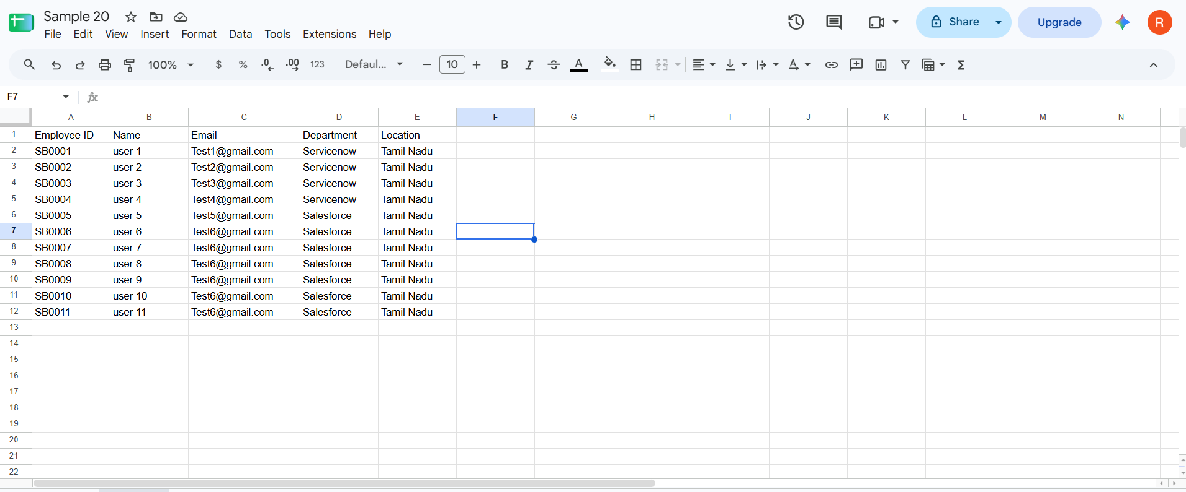
3.Download the spreadsheet as Sample Spreadsheet.xlsx format.
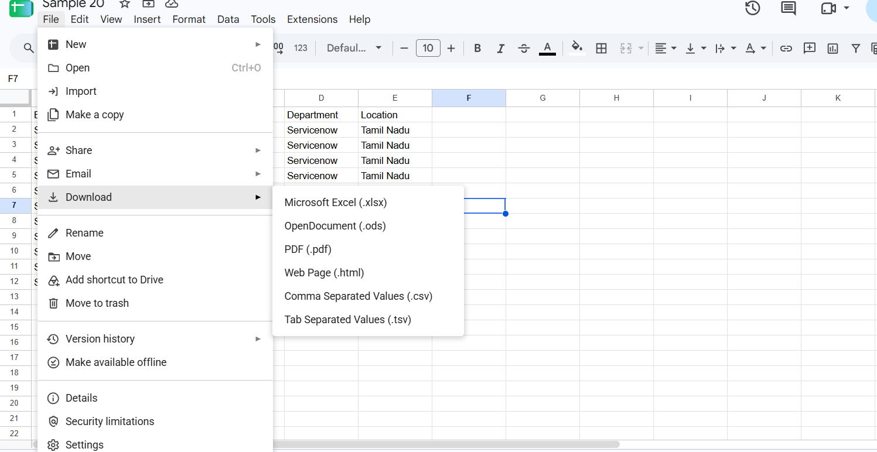
- Creation of Tables
Create new Custom table
Navigation:
1.Tables > Create New
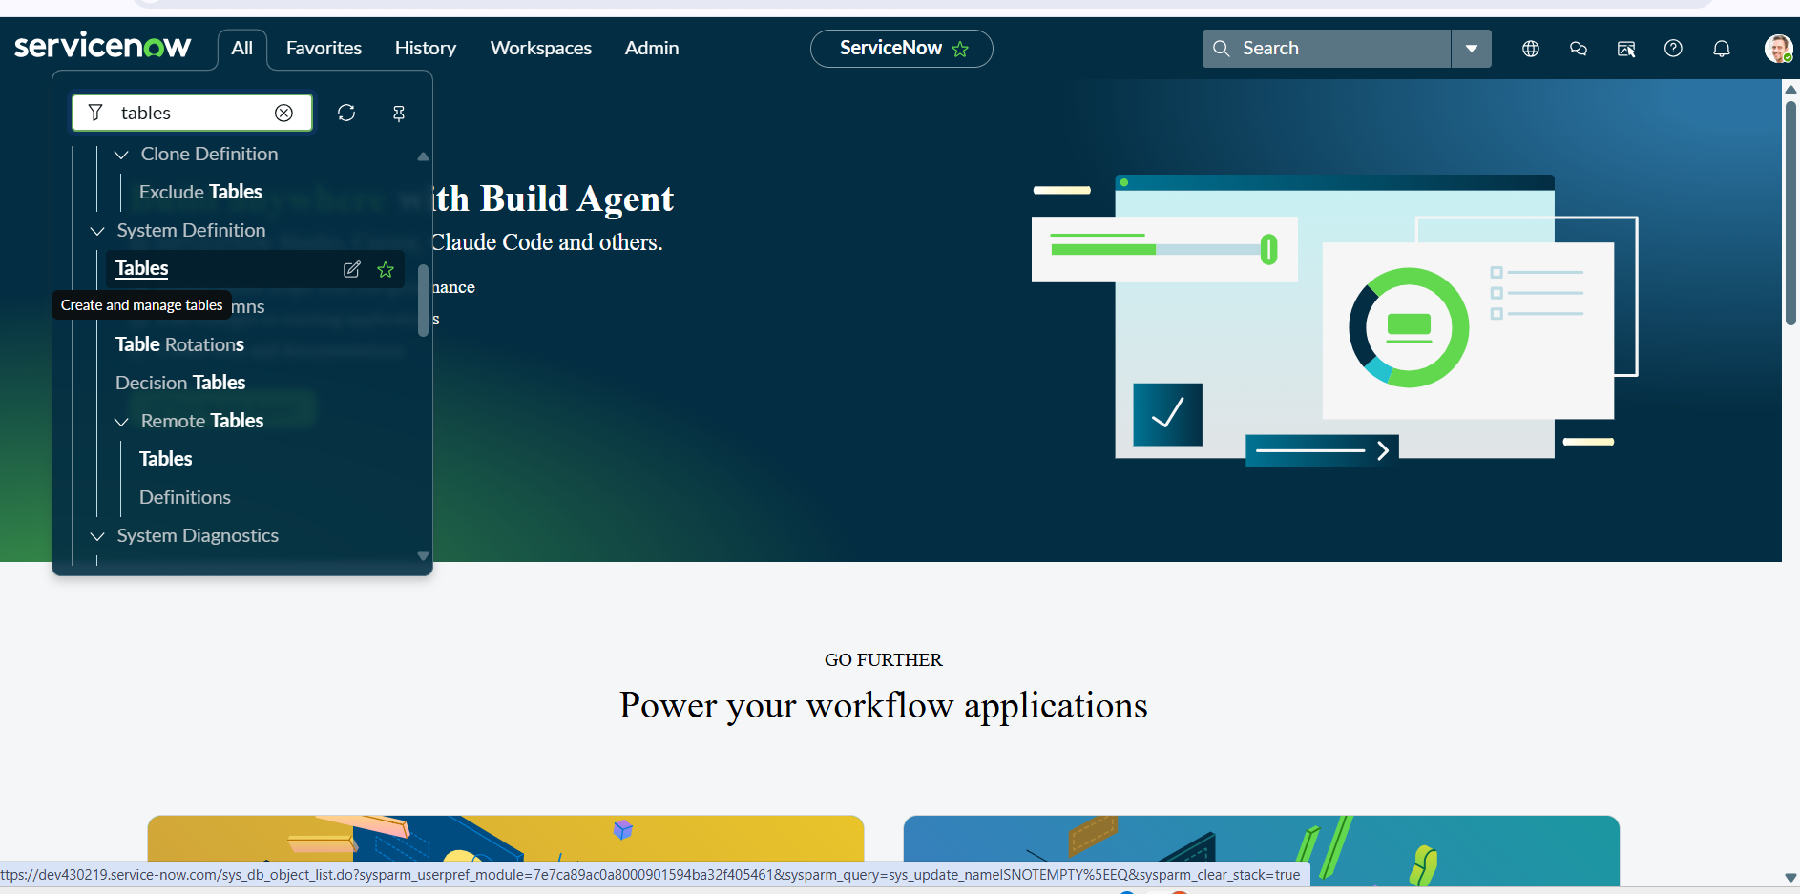
2.Label: Employee Test Name: u_employee_test
3.After creating and saving the Employee Test table
4.scroll down and go to related links
5.click on show form
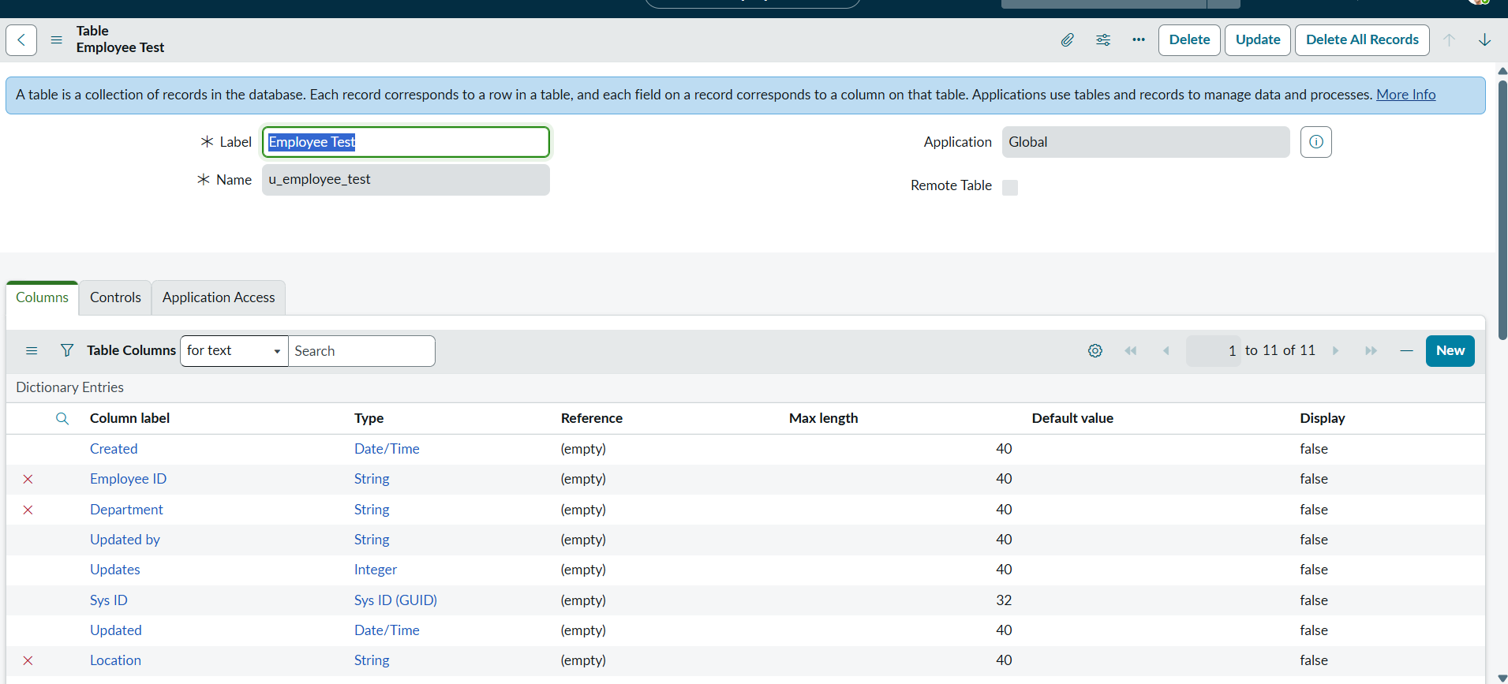
6.On the form, locate the Form Context Menu / Additional Actions option on the left side of the form header.\
7.Click the Form Context Menu / Additional Actions icon.
8.Click configure , select Form Layout.
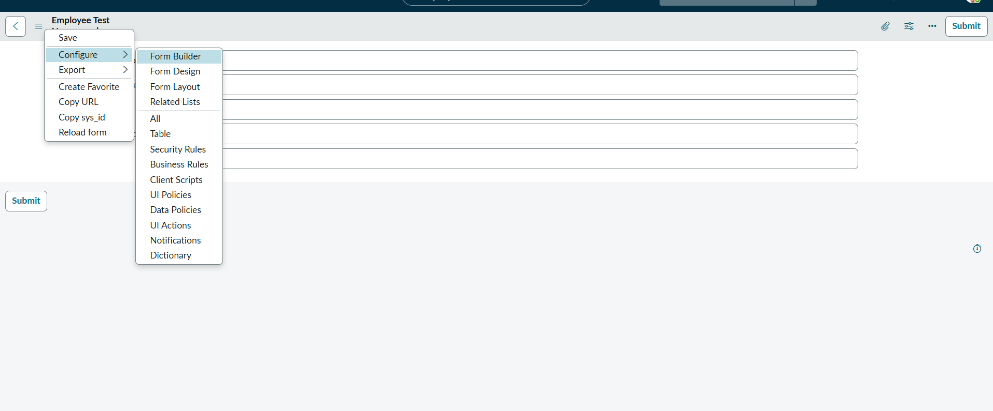
9.The Form Layout page will open, where you can configure the fields displayed on the form
10.After opening Form Layout, click New to create a new field.
11.Enter the field details:
Column Label: Employee ID
Type: String
Click Add to create the field.
12.Repeat the same steps to create the following fields:
Employee Name – Type: String
Email – Type: String
Department – Type: String
Location – Type: String
13.After creating all the required fields, click Save.
14.Verify that the newly created fields are displayed on the Employee Test form
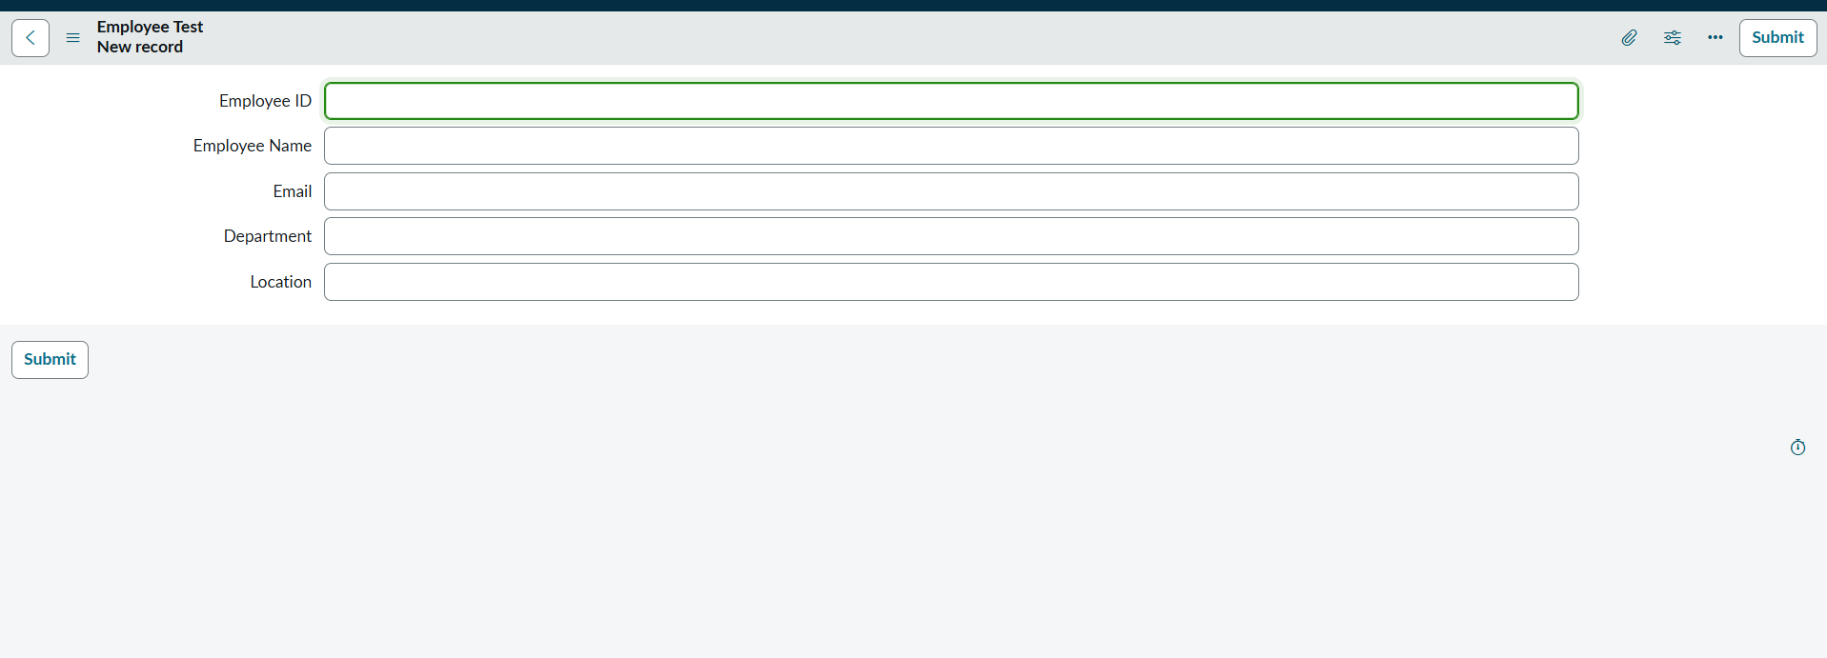
15.Click on Submit or Save.

Milestone 2 : Creation Of importset Table And Transform Map
- Create Importset Table
Navigation:
1.Go to Application Navigator
2.Load Data
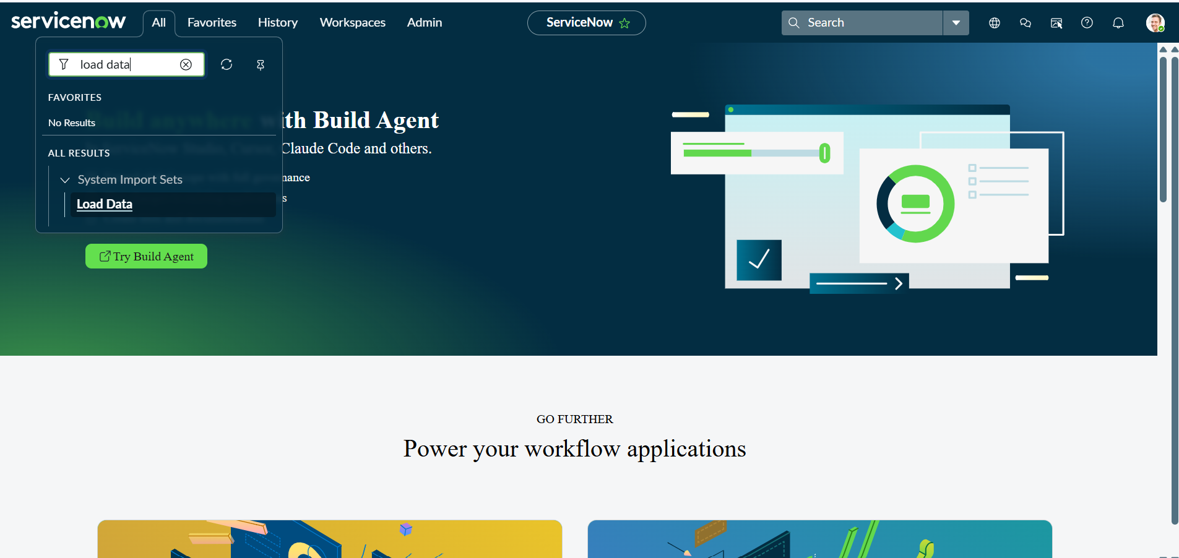
3.Click on Load Data and create an import table
4.Fill details as shown below
5.Label: Employee Import
6.Name: u_employee_import (auto populated)
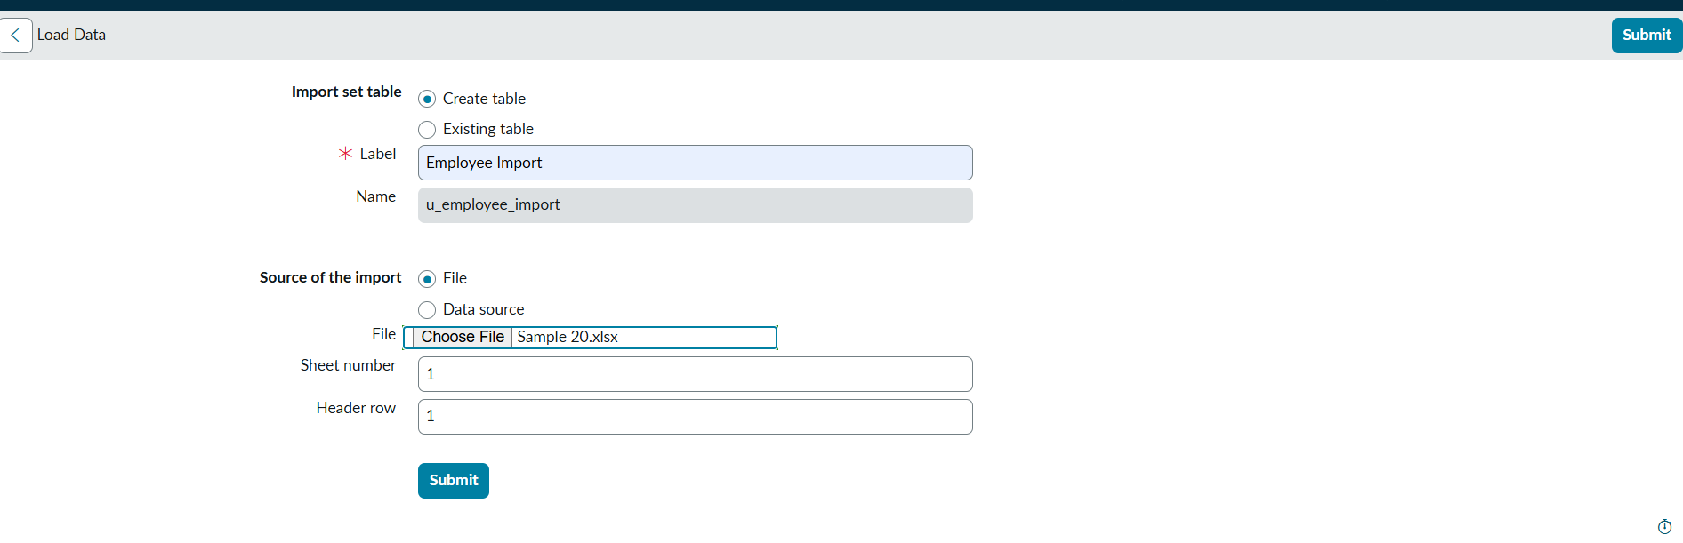
7.Click on Submit
8.Once we click on Submit, we can see the success message as shown below.
9.Also we need to make sure to click on Create Transform Map.
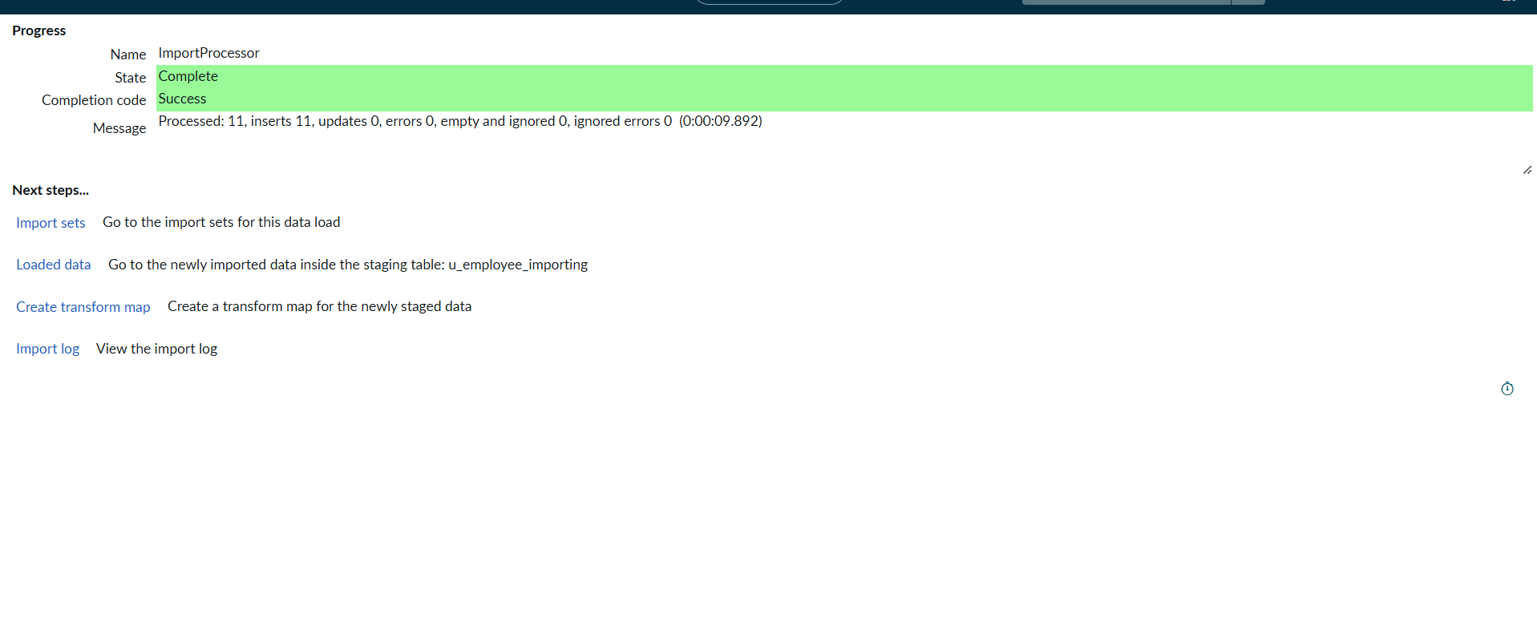
- Create Transform Map
1.Give inputs as shown below.
2.Name: Sample Spreadsheet Import
3.Source Table: Employee Import is auto-populated
4.Target Table: Employee Test - as we created earlier
5.Click on Auto Map Matching fields.
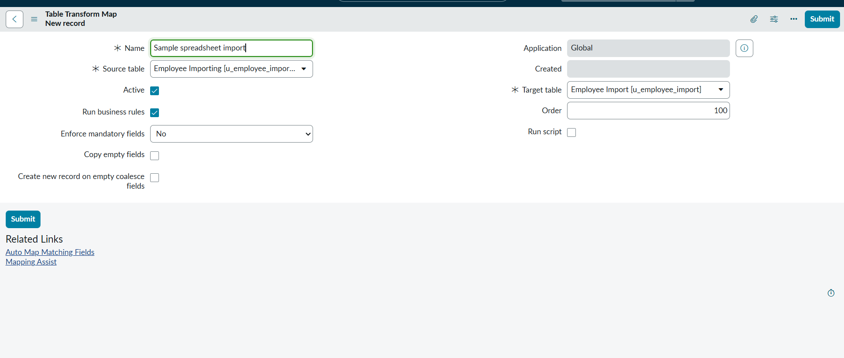
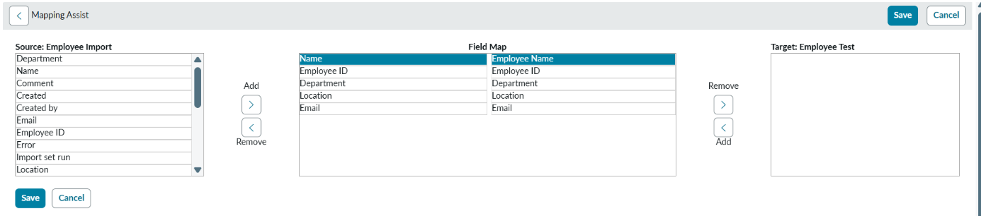
6.Click on Save
7.Make sure the both Source & Target table fields are mapped as shown below.
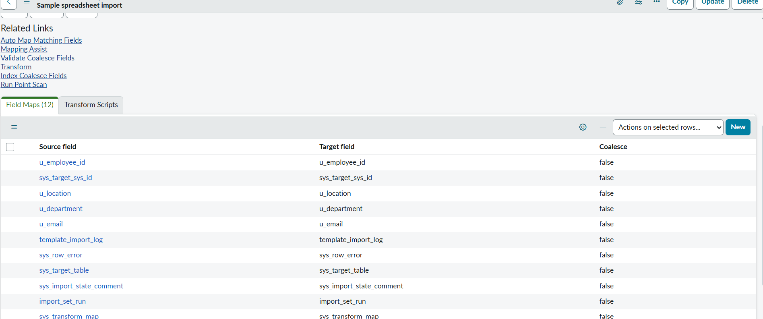
8.Now click on Transform as shown below
9.Now click on Transform as shown below
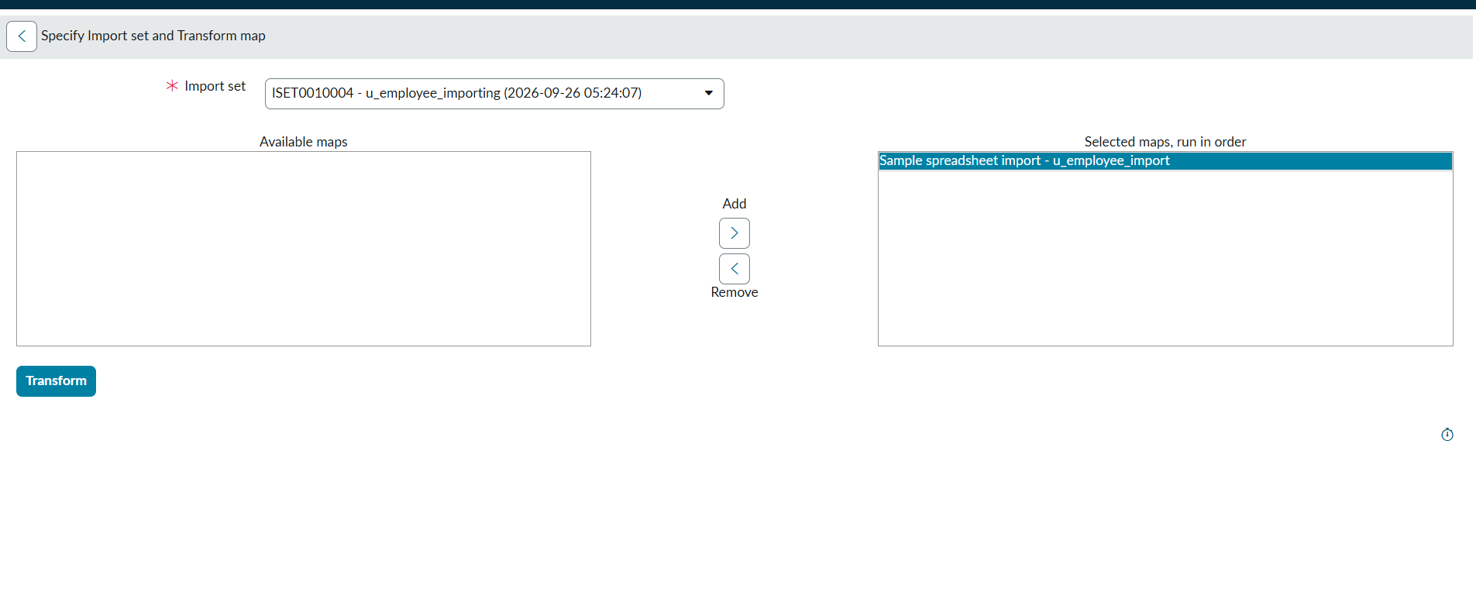
10.After clicking Transform, make sure you see the success message as shown below.
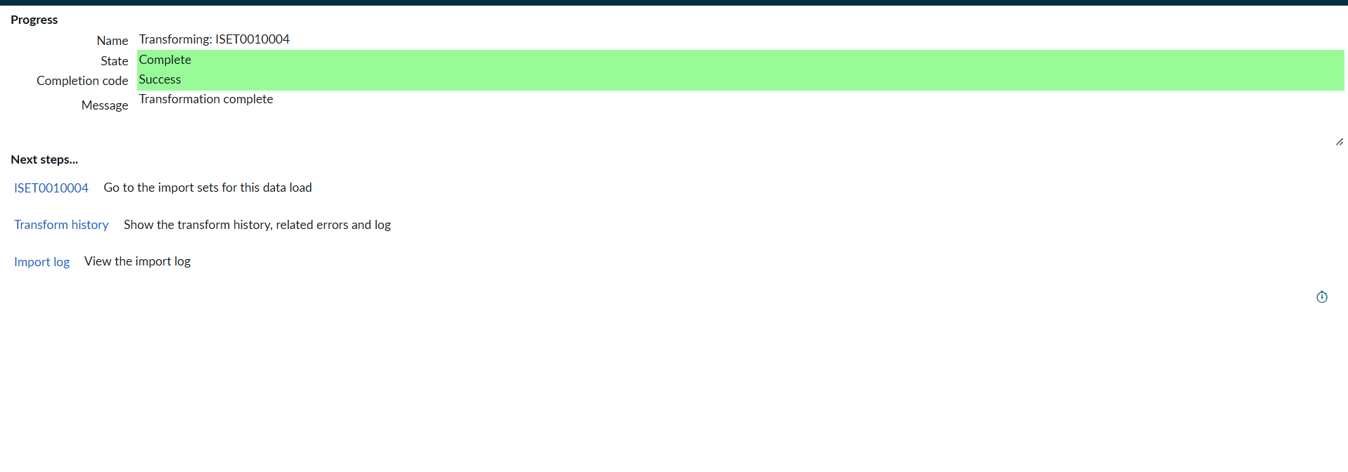

Milestone 3 : Transform Data & Validate And Enable Coalesce to Avoid Duplicate Records
- Transform Data & Validate
Navigation:
1.Open Employee Test Table from application navigator as shown below.
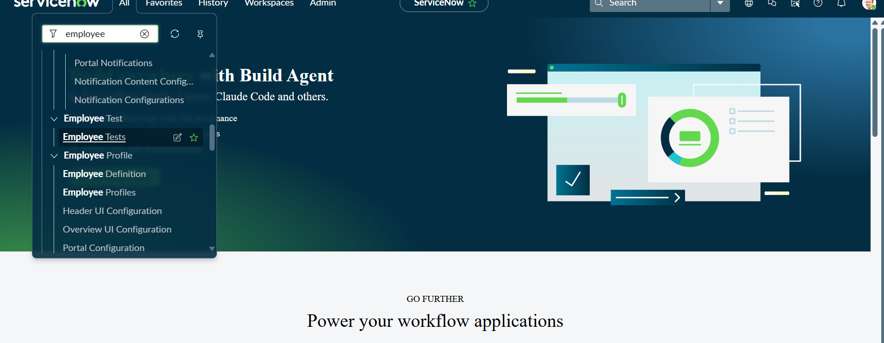
2.As our import got succeeded, all the records are created in the Employee Test Table.
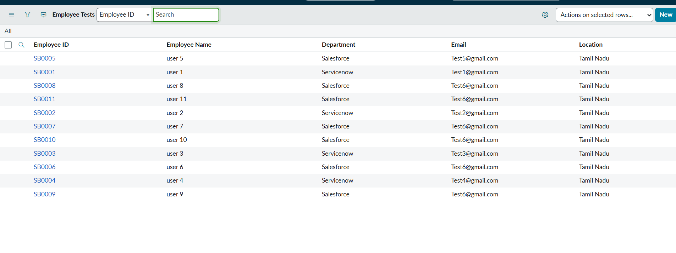
3.Make sure you rearrange the fields accordingly by using Personalised List Columns
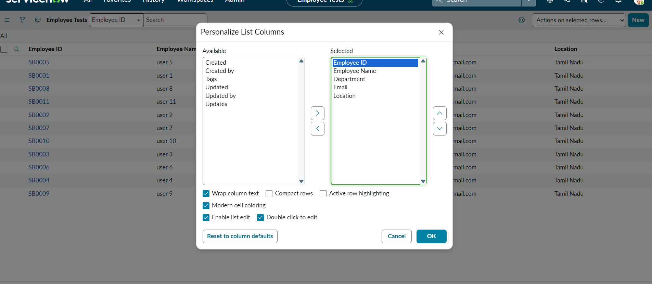
4.Click on OK
Final Result:
All the records are successfully imported into the ServiceNow system with Import Set, Transform Map.
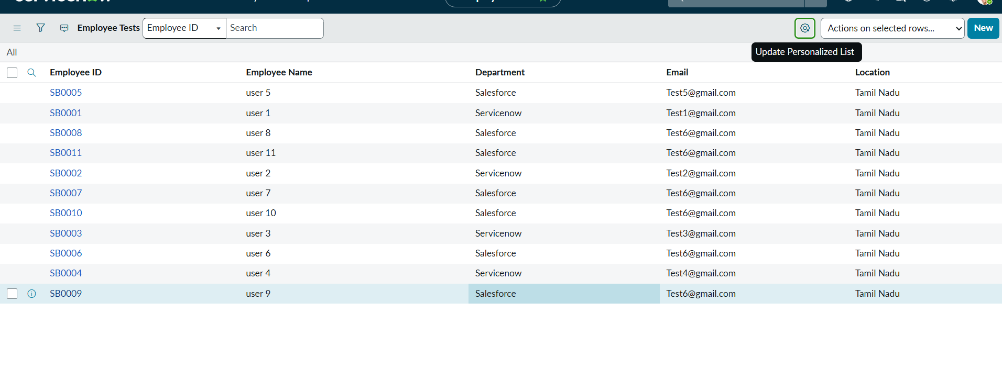
- Enable Coalesce to Avoid Duplicate Records
Steps:
1.Open Transform map Under System import sets On All menus.
2.Open the Created Transform map , Name is Sample Spreadsheet Import.
3.Under Related list, select the Field maps Section and Make any one field Coalesce True which appears in False.
4.Now save the form.
5.Then again add some data which is in Excel format.
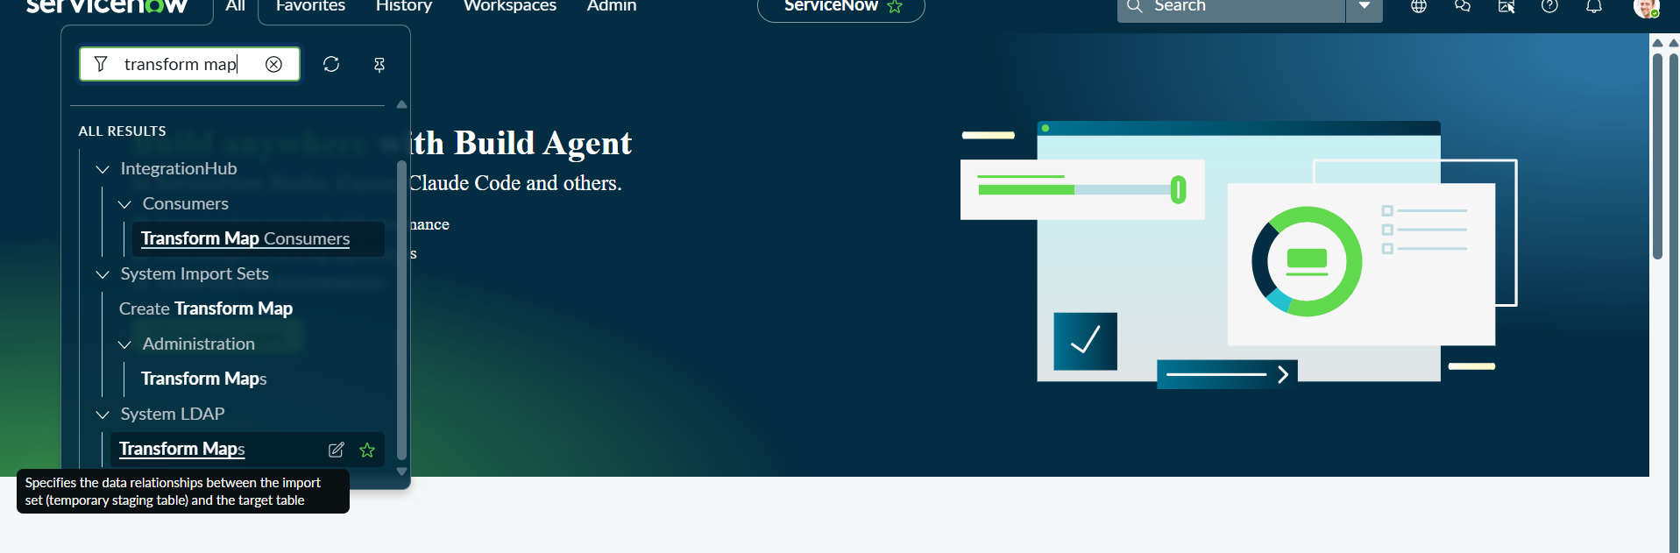
6.Open Transform map Which You are Created
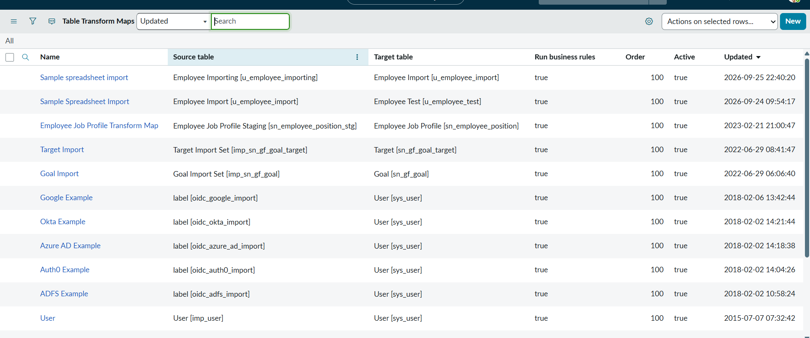
7.Go to field mapping
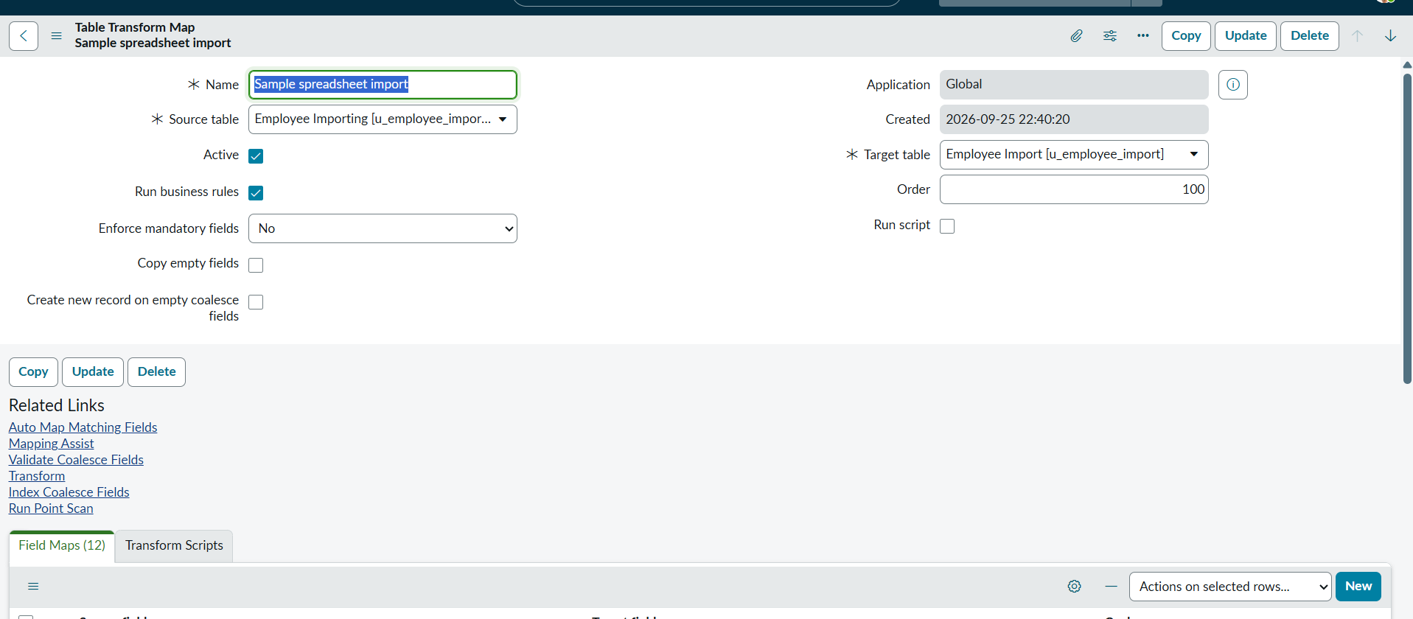
8.Go to coalesce field make true for one unique field
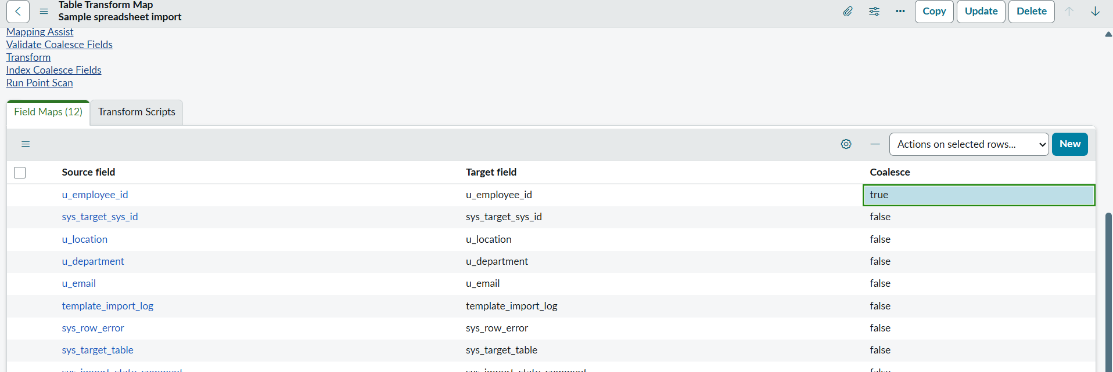
- Inserting New Data In Excel Format
Steps :
1.Navigate to All menus.
2.Search for Load data Under System Import set Open Load Data.
3.Fill the details as
4.Import set table as select Existing table {Employee Import}.
5.Source of Import is Select File and choose the file from Files.
6.Sheet number : 1, Header row : 1.
7.Now Click submit.
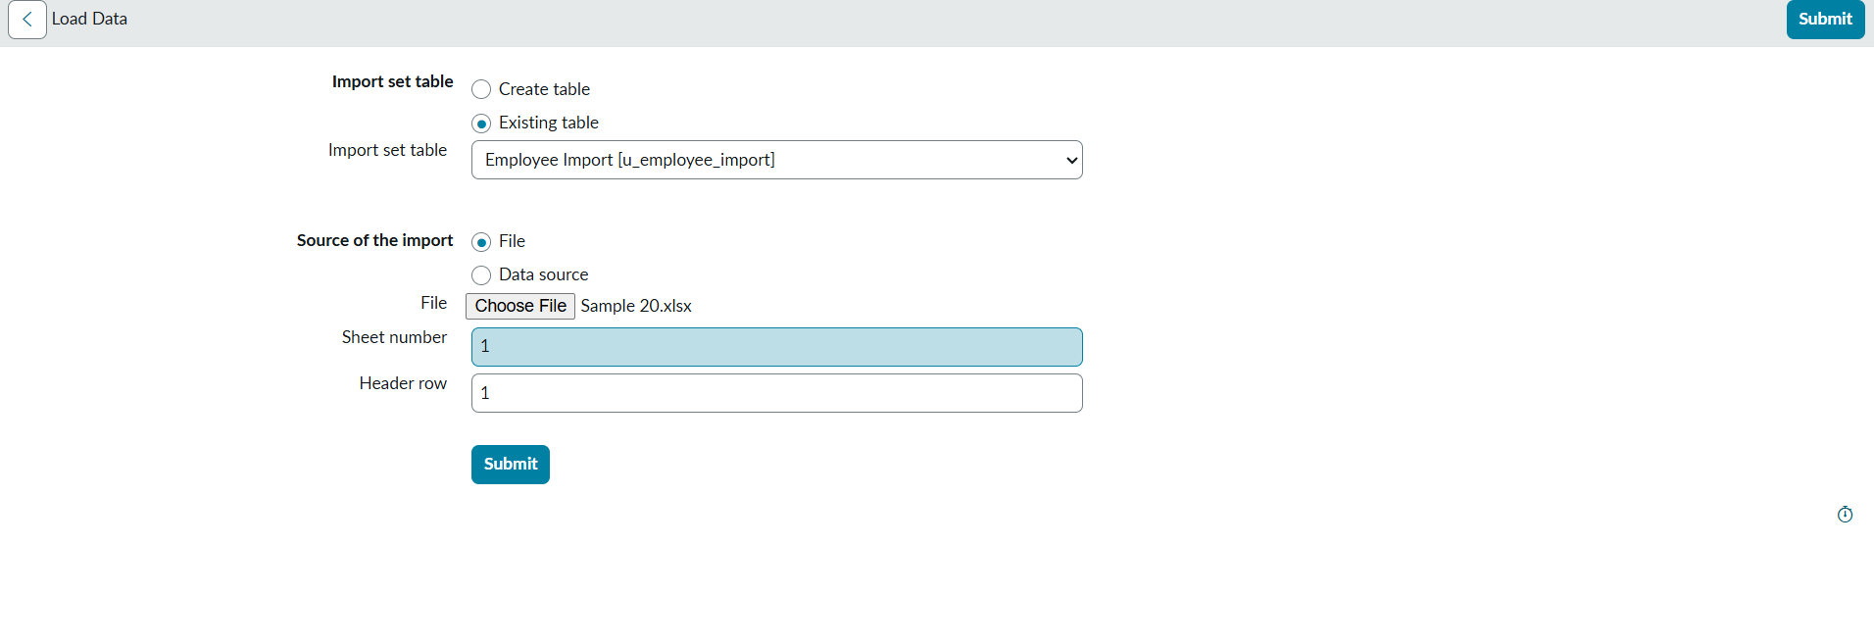
8.Newly Created Excel Data is this.
9.It is the previously added data.
10.Now, In this new data we added 4 rows of the 2 rows with the same existing data with different Name changed and Email changed.
11.That Raviteja Employee Email was Changed to
[test10@gmail.com → test18@gmail.com ].
12.And Employee ID with SB-OOO4 name was changed to
[Ajay kumar → Ajay].
13.And two other new Employee ID’s are added.
14.Now after submitting the form it appears as State Completed and Success.
15. Now Click the Run transform Under the next steps.
16.Then it opens Specify Import set and transform map which is previously selected transform map then Click Transform button.
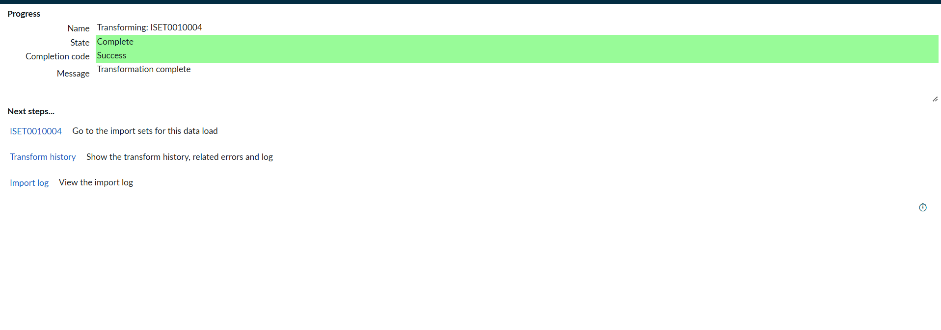
17.Now the State is completed and Success.
18.Now again click on the Transform history then it shows the newly added data and its status of Inserted and Skipped values out the given data.
19.From the above figure : total 4 rows are uploaded out of 2 are Inserted that are two new ID’s.
20.And 2 rows are updates that are Same ID’s with different Name and different Email that we changed.
21.Then Open the Employee Tests table and see the rows updated and inserted.
22.Now Repeat the Phase 7 with the same steps and same Excel sheet and Submit to check how many rows are updated and Inserted with the same data.
23.Then Open the Transform history to check
24.Here we can see the total 4 are uploaded.
25.On that 0 rows are Inserted and updates 0 and Ignored 4 rows.
26.That same sheet we uploaded to the same transform map we create

Milestone 4 : Creation Of reports & dashboards
- Report 1
Create Reports on Employee Test Table
Navigation Steps :
1.Open All menus, Search for Reports.
2.Under Usage and governance Select Reports.
3.Click the New button to create a new report.
Report 1: Employees by Department
1.In Data
2.Report name : Employees by Department.
3.Source Type : Table.
4.Table : Employee Test, Now click the Next button.
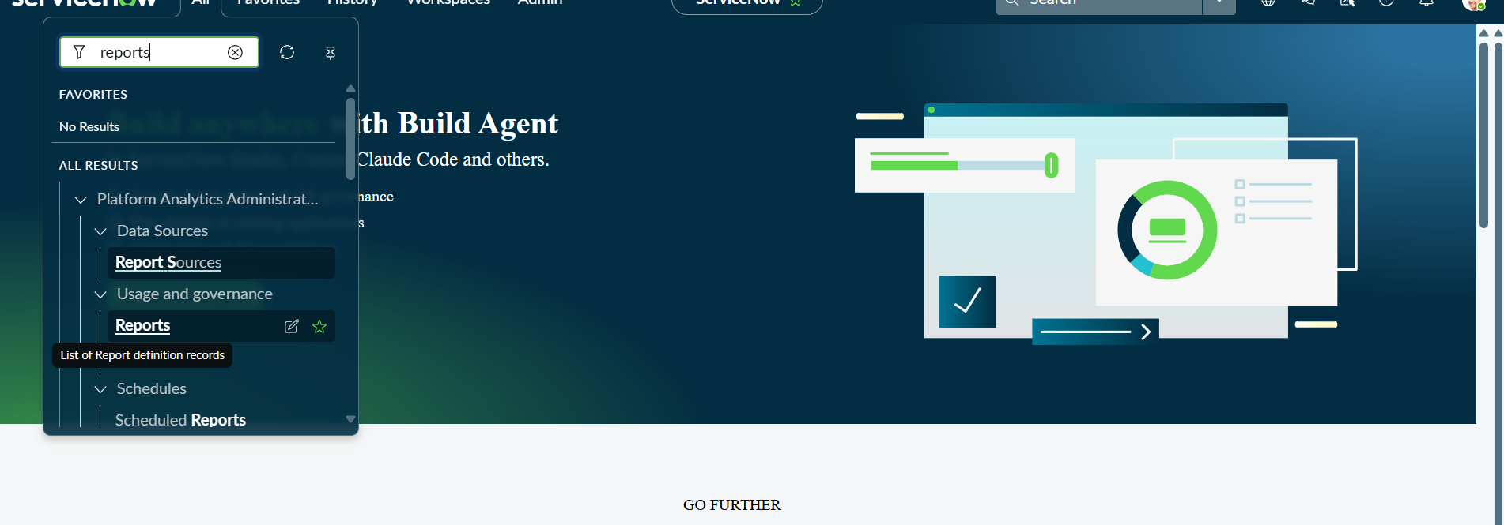
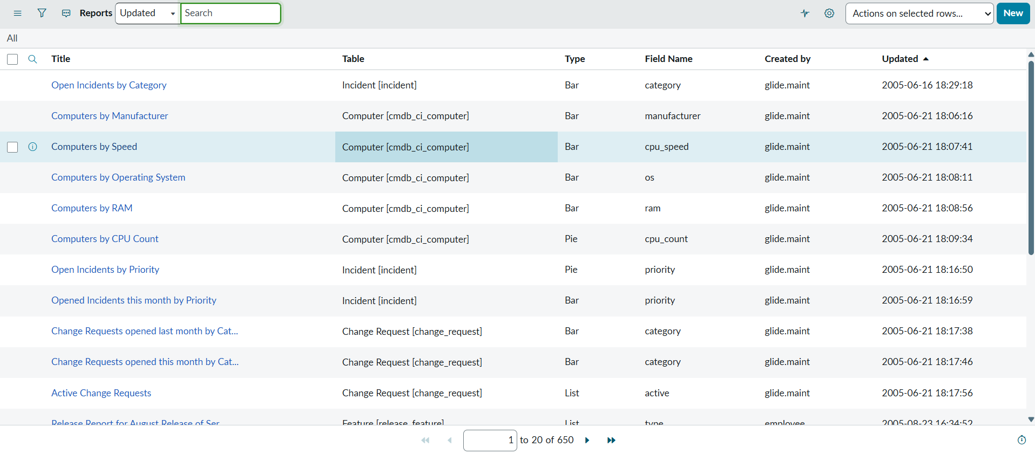
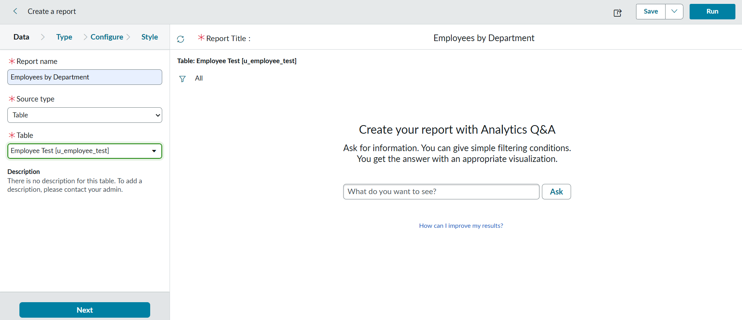
5.Now after Clicking next in type Select Pie chart .
6.And click the next button
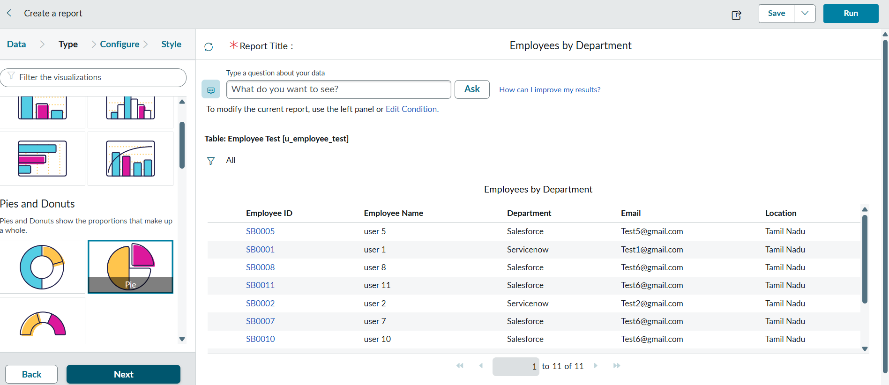
7.Now In Configure Select Group by Department Field.
8.In the Aggregation Field Select Count.
9.Then Click next.
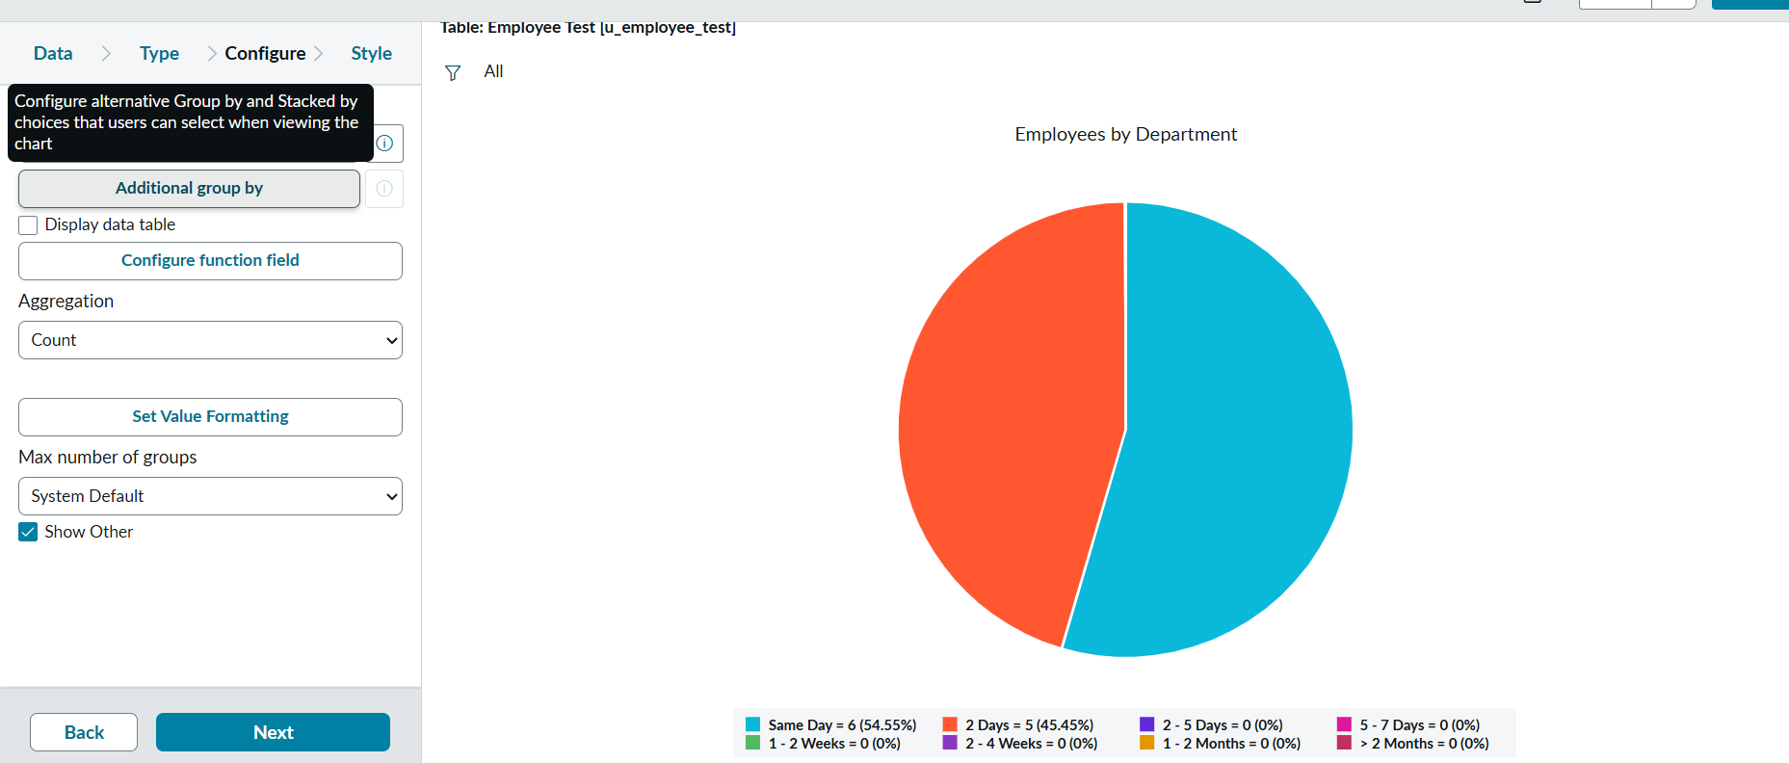
10.Now In Style Leave the Chart color by default.
11.And Click the Run button to Execute the given data Report.
12.And Click save button to Save the Report.
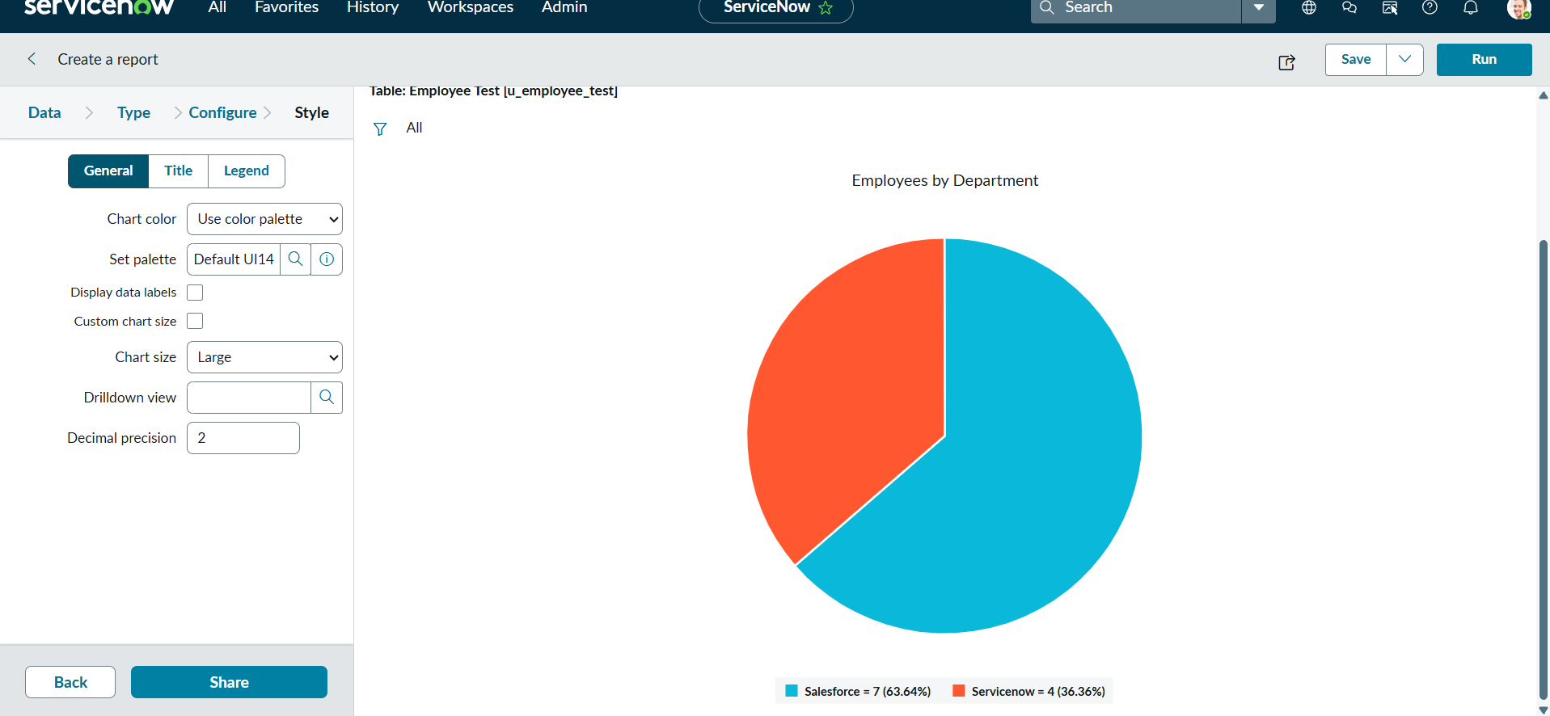
- Adding Reports to Dashboard
Create Dashboard
Navigation :
1.Open All menus → Search for Dashboards.
2.Under Self Service → Click Dashboards.
3.On the top right corner Click Create Dashboards or
4.You can create Directly by using the backend name[ PA_DASHBOARDS.FORM ].
5.Then Click New to Create new Dashboards.
6.Only the backend name will open the form if the ACL has the pa_dashboards access to Admin Overrides True only.
7.Then only we have access to the form
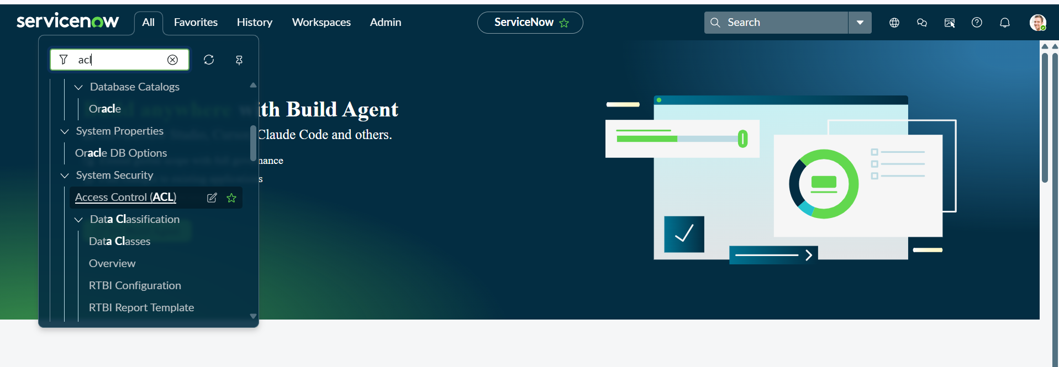
8.After Opening the ACL Search the pa_dashboards on Name Column
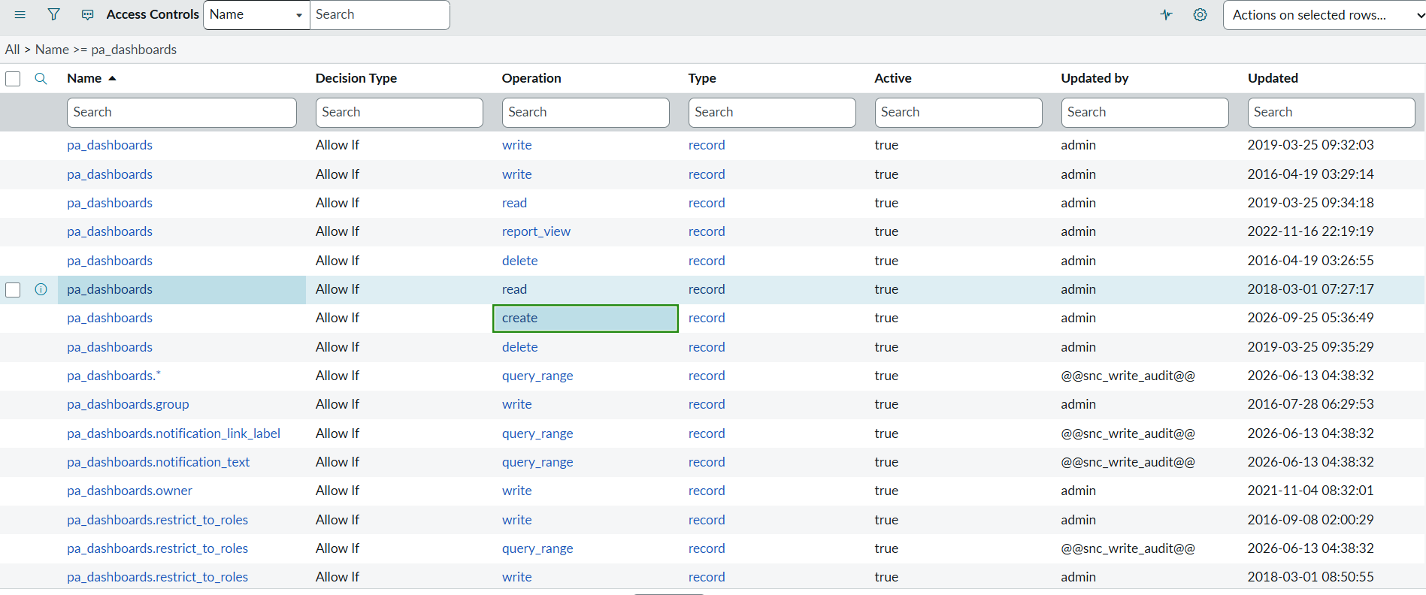
9.Now Open the Create Operation row
10.Then Click Enable the True for Admin Overrides and Update the Form.
11.Then the creation of dashboards will be possible by using the backend name.
12.Now Open the PA_DASHBOARDS.FORM create dashboard.
13.Dashboard name : Employee Analytics Dashboards.
14.Save the Form.
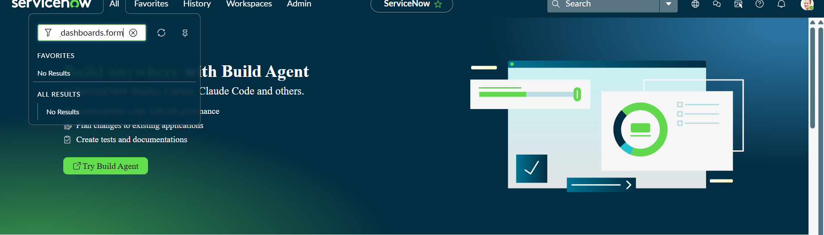
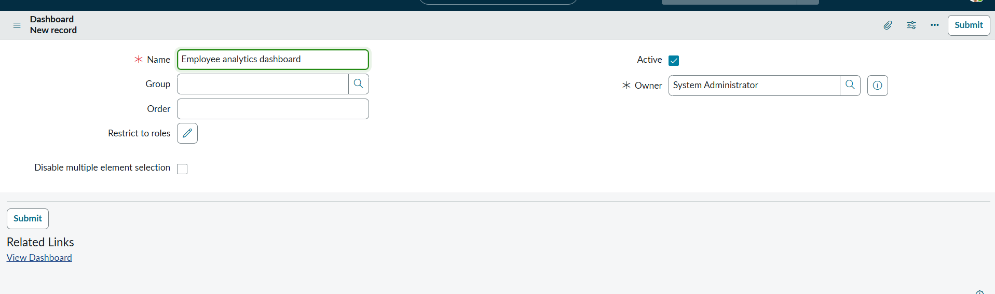
Add Reports to Dashboards
Navigation Steps:
- Open the Previously Created Reports.
- On All menus → type Reports Under Usage and Governance select reports.
- Open the Employees by Department.
- Select the Edit Report and Click the Share button then the right top corner Select the Add to Dashboards Option.
- Then Choose the Created dashboard name and Click Add button
- Same Like that do the remaining 2 reports in the same navigation how we added Employees by Department.
- The Employees by Location and Employee List Report these two reports are also added to the created dashboard.
- After Opening the Report Click the View Report Button on the right side of the Context menu.
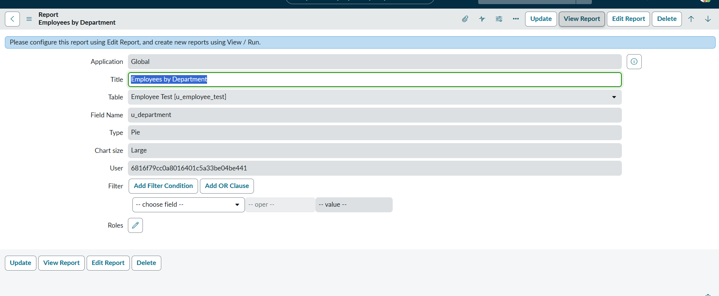
- After Clicking the View Report button, Now Click the Share button and then share options are visible on the right side.
- Now click the Add to Dashboards
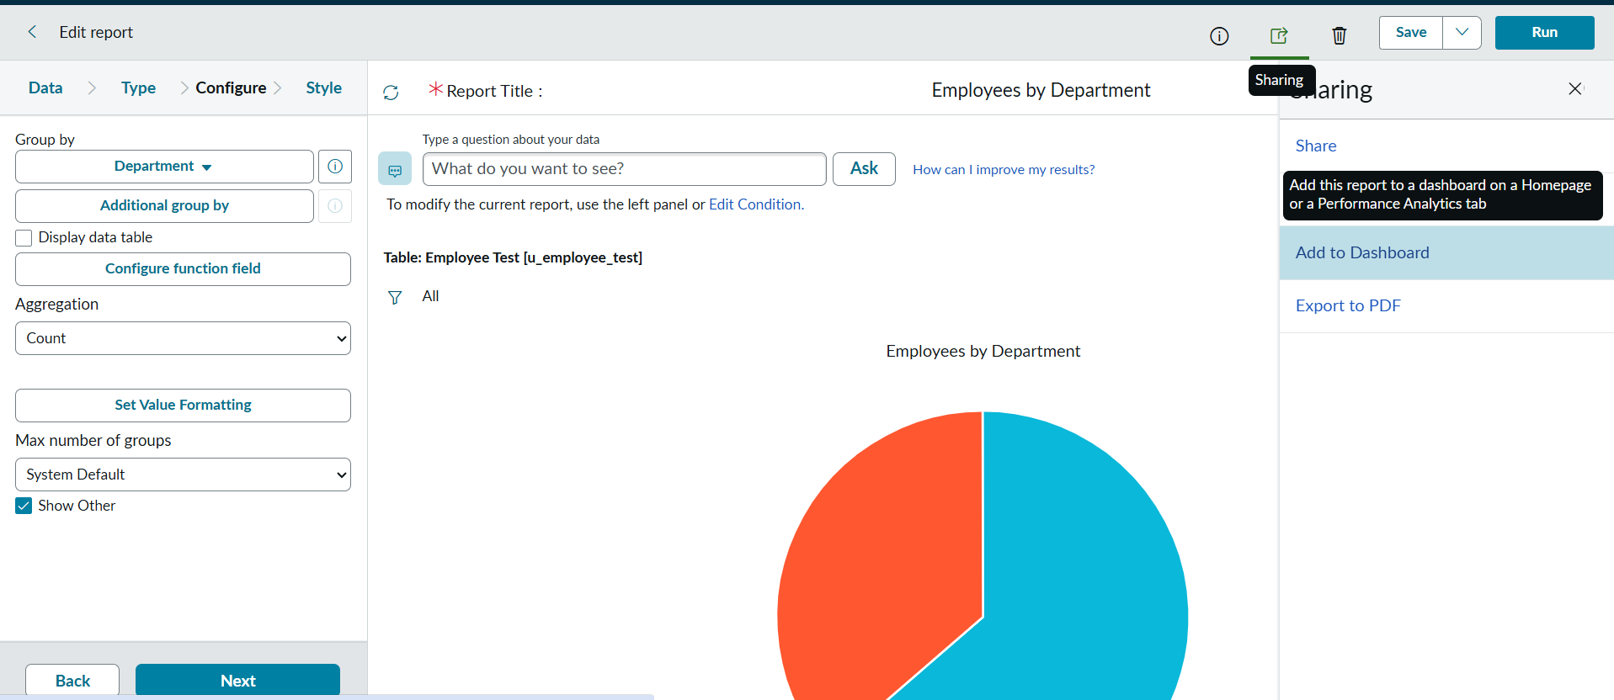
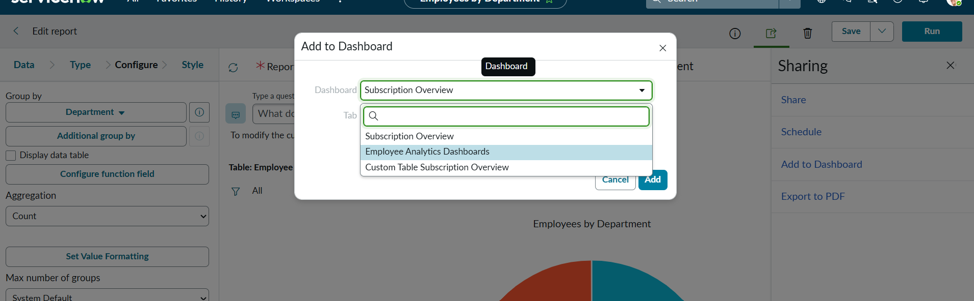
- Now Add the Dashboard that you created called Employee Analytics Dashboards.
- Then Click Add button.
- Now the Report is added to the dashboards.
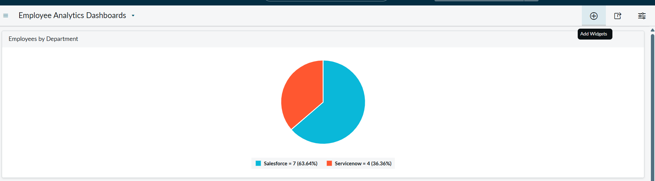
- From the + icon also we add widgets that our reports from there.
- If we want we can also configure the background color
- Here the three Reports are added successfully by varying Department , Location and List Report.
- We can also restrict the Users,Groups and Roles From Share Option.

ADVANTAGES:
- Imports large amounts of spreadsheet data quickly.
- Maps spreadsheet fields to ServiceNow fields easily.
- Reduces manual data entry.
- Helps identify and avoid duplicate records.
- Allows data to be transformed during import.
DISADVANTAGES:
- Incorrect data can cause import errors.
- Requires some ServiceNow knowledge to configure
- Incorrect mapping can update the wrong data.
- Large imports may take more time to process
- Transform Maps may need maintenance when data formats change.

PROJECT OUTCOME:
- Successfully imported spreadsheet data into ServiceNow using Import Sets and Transform Maps.
- Mapped source spreadsheet fields to the appropriate target table fields.
- Applied data transformation and validation during the import process.
- Reduced manual data entry and improved the accuracy of data migration.

